1. The tracert utility is used to trace the path packets take from your computer to a specified

destination. It helps identify where delays or connectivity issues occur along the route.

tracert [options] destination

To route a website,

tracert [www.google.com](http://www.google.com)

To route to local host

tracert 127.0.0.1

1. **Hop Number**: Sequential number indicating the order of routers encountered.

**IP Address**: The address of the router at each hop.

**Round-Trip Time (RTT)**: The time it takes for a packet to travel to the hop and back.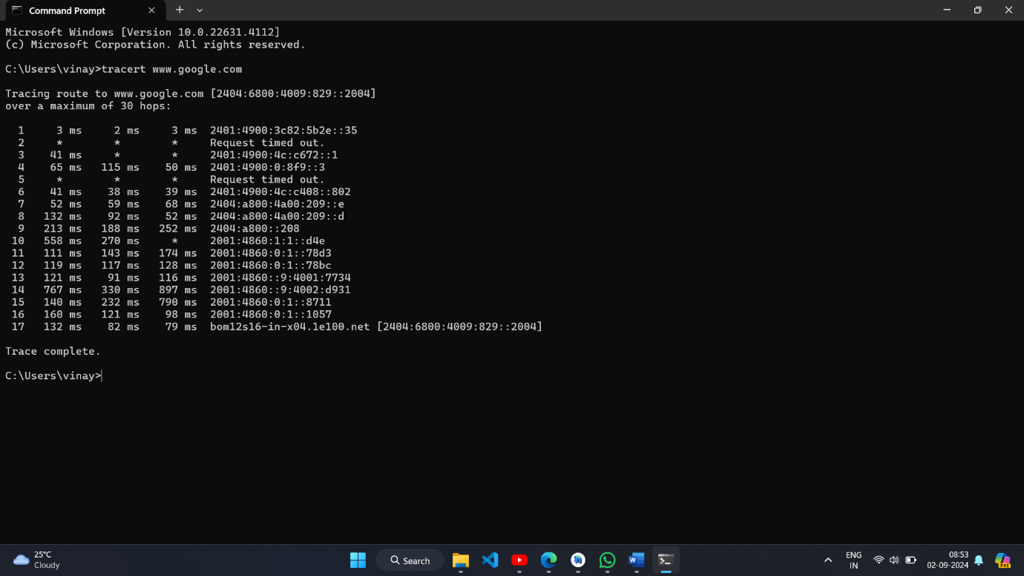

3. -d (Do Not Resolve Hostnames)

Prevents tracert from resolving IP addresses to hostnames

-h (Maximum Number of Hops)

Limits the number of hops to attempt.

-w (Timeout in Milliseconds)

Sets the time to wait for each reply.

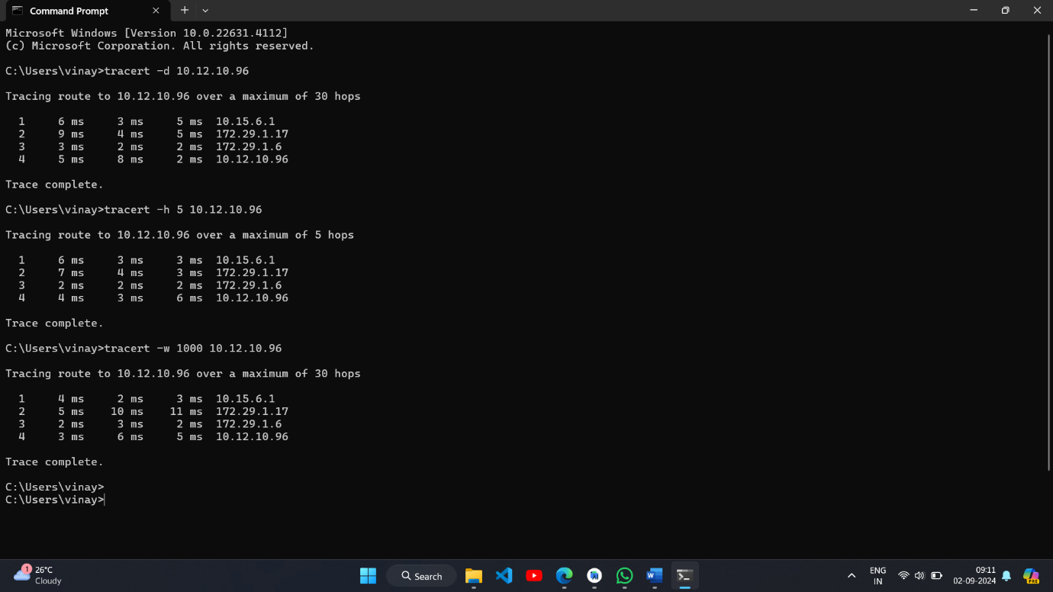

4.Use tracert when experiencing connectivity issues, e.g., slow internet speeds.

If the issue is in the local network, the first few hops will show delays or timeouts.

Use -d to quickly identify IPs causing delays and -h to limit the hops if you want to test up to a certain point.